FINAL PROJECT REPORT
SWYNEX Cafe Sales Analytics
End-to-End Data Analytics Project: Data Cleaning, Exploratory Analysis, Interactive Dashboard and Business Insights
Project detail | Description
Project title | Interactive Cafe Sales Analysis
Author | Pritam Dey
Report date | September 30, 2026
Dataset | Cafe sales transactions, 10,000 records, 1 January 2023 to 31 December 2023
Tools used | Python (Pandas, NumPy) on Google Colab; Microsoft Excel (Pivot Tables, Charts, Slicers); Microsoft Power BI (DAX measures, interactive report)
Deliverables | Cleaned dataset, Cleaning notebook, Excel EDA workbook, Power BI dashboard (.pbix), Dashboard README, this report

Table of Contents
1. Executive Summary
2. Problem Statement and Objectives
3. Project Scope, Tools and Workflow
4. Dataset Information
5. Data Cleaning and Preparation
6. Exploratory Data Analysis (Excel)
7. Interactive Dashboard (Power BI)
8. Key Business Insights
9. Data Validation Review
10. Business Recommendations
11. Limitations and Assumptions
12. Conclusion
Appendix A: Key Cleaning Code
Appendix B: Glossary
Appendix C: Author and Verification

1. Executive Summary
SWYNEX is an end-to-end analytics project built on a cafe sales dataset of 10,000 transactions recorded across the 2023 calendar year. The raw file was deliberately "dirty": placeholders such as ERROR and UNKNOWN, blank cells, and inconsistent data types were spread across every analytical column. The project takes this raw data through a complete analytics workflow: profiling and cleaning in Python, exploratory analysis in Excel, an interactive three-page dashboard in Power BI, and a set of quantified business insights for management.

$89,290.50  Total Revenue | 10,000  Transactions | 30,271  Units Sold | $8.93  Avg Transaction | 3.03  Avg Qty / Transaction

Headline findings as reported in the dashboard
- Juice is the largest revenue product ($19,075.50, 21.36% of revenue) and the highest-volume product (6,435 units).
- Four products (Juice, Salad, Sandwich, Smoothie) contribute about 71.16% of total revenue.
- Digital Wallet is the leading payment method ($48,354; 54.15% of revenue).
- Takeaway is the leading channel ($62,039; 69.48% of revenue; 6,983 transactions).
- July is the peak month ($11,058.50), about 55.5% above the average of the other months; February is the lowest ($6,657.50).
- Potential high-value transactions are only 2.68% of transactions (268) but contribute about 7.50% of revenue ($6,700); Salad accounts for about 92% of that high-value revenue and has the highest average transaction value (about $15.12).

2. Problem Statement and Objectives

2.1 Background
Cafe operators generate large volumes of transaction data every day, but raw point-of-sale exports are rarely ready for decision making. They contain missing entries, system error codes, inconsistent formats and no summarised view of performance. Without a clean, centralised and interactive view of sales, management cannot easily tell which products drive revenue, how customers pay, which channel performs best, when demand peaks, or which transactions carry unusually high value.

2.2 Problem Statement
How can raw, error-prone cafe transaction data be cleaned, analysed and presented as an interactive business-intelligence solution that clearly shows revenue, product, payment, channel, seasonal and high-value transaction performance, so that management can make informed decisions on products, promotions and sales planning?

2.3 Project Objectives
- Assess the quality of the raw dataset and identify all missing, invalid and inconsistent values.
- Clean and standardise the data into an analysis-ready dataset with correct data types and no missing values.
- Perform exploratory data analysis (EDA) in Excel to compute descriptive statistics, product, payment, location and monthly performance, and detect outliers.
- Design an interactive Power BI dashboard with KPI cards, trend and category visuals, and slicers for drill-down analysis.
- Convert the analysis into quantified, management-level business insights.
- Document the full workflow, findings, limitations and recommendations.

2.4 Business Questions the Project Answers
Area | Business question
Overall performance | How much revenue is generated? How many transactions and units? What is the average transaction value and average quantity per transaction?
Products | Which products contribute the most revenue? Which have the highest sales volume? How concentrated is revenue across products?
Payments | Which payment method contributes the most revenue?
Location / channel | How does revenue differ between Takeaway and In-store?
Time | How does revenue change month by month? Which months are highest and lowest?
High-value sales | Which transactions qualify as potential high-value transactions? Which products dominate them? What share of transactions and revenue do they represent?

2.5 Business Problems Addressed
# | Business problem | How the project addresses it
1 | Lack of centralised sales visibility | KPI cards consolidate revenue, transactions, units, average transaction value and average quantity in one view.
2 | Difficulty identifying top-performing products | Revenue-by-item and quantity-by-item visuals rank products by financial contribution and volume.
3 | Revenue concentration risk | Revenue concentration analysis shows dependence on a small group of products.
4 | Limited understanding of payment behaviour | Payment-method revenue analysis shows which modes contribute most.
5 | Unclear location / channel performance | Revenue by location compares Takeaway with In-store.
6 | Difficulty detecting seasonal or monthly patterns | Monthly trend plus highest / lowest month measures.
7 | Difficulty identifying high-value sales opportunities | Dedicated high-value transaction, revenue and percentage measures.
8 | Unknown drivers of valuable transactions | High-value transactions by item show which products dominate.
9 | Static reporting and limited drill-down | Five interactive slicers filter every visual dynamically.
10 | Gap between operational metrics and management insight | Business Insights and Executive Insights pages state quantified findings.

3. Project Scope, Tools and Workflow

3.1 End-to-End Workflow
Stage | Tool | Input | Output
1. Data profiling and cleaning | Python (Pandas, NumPy) in Google Colab | dirty_cafe_sales.csv | cleaned_cafe_sales.csv
2. Exploratory analysis | Microsoft Excel (formulas, Pivot Tables, charts, slicers) | cleaned_cafe_sales.csv | SWYNEX_Exploratory_Data_Analysis.xlsx
3. Interactive dashboard | Microsoft Power BI (DAX, DateTable, slicers) | Cleaned data model (CafeSales + DateTable) | SWYNEX-Interactive-Dashboard.pbix
4. Documentation and insights | Markdown README and this report | All project files | README and Final Project Report

3.2 Scope
- In scope: data quality assessment, cleaning, feature preparation, descriptive and diagnostic analysis, dashboarding, and insight generation for the 2023 calendar year.
- Out of scope: cost, margin and profitability analysis, customer-level segmentation, forecasting, and time-of-day analysis (the dataset contains no such fields).

3.3 Project Files
File | Type | Purpose
dirty_cafe_sales.csv | Raw data (550 KB) | Original transaction export with errors and missing values
SWYNEX_Data_Cleaning_Preparation.ipynb | Jupyter notebook | Documented cleaning and preparation process
cleaned_cafe_sales.csv | Clean data (610 KB) | Analysis-ready dataset (10,000 rows, 8 columns)
SWYNEX_Exploratory_Data_Analysis.xlsx | Excel workbook | Five sheets: cleaned data, calculations, pivot analysis, dashboard, insights
SWYNEX-Interactive-Dashboard.pbix | Power BI report | Three-page interactive dashboard
SWYNEX-Interactive-Dashboard-README.md | Documentation | Dashboard documentation, measures and findings

4. Dataset Information

4.1 Dataset Overview
Attribute | Detail
Subject | Cafe point-of-sale sales transactions
Records | 10,000 transactions (one row per transaction)
Columns (raw) | 8
Period covered | 1 January 2023 to 31 December 2023 (all 365 dates present in the cleaned data)
Unique Transaction IDs | 10,000 (0 duplicate IDs, 0 fully duplicated rows)
Menu items | 8: Cake, Coffee, Cookie, Juice, Salad, Sandwich, Smoothie, Tea
Payment methods | 3: Cash, Credit Card, Digital Wallet
Locations | 2: In-store, Takeaway
Raw file quality | Every column except Transaction ID contained blanks, ERROR or UNKNOWN entries; only 3,089 rows (30.89%) were fully valid

4.2 Data Dictionary
Column | Type (raw to clean) | Description | Values / range
Transaction ID | Text | Unique transaction identifier | TXN_xxxxxxx, 10,000 unique
Item | Text | Menu item sold | 8 items
Quantity | Text to integer | Units sold in the transaction | 1 to 5
Price Per Unit | Text to decimal | Unit price in dollars | $1.00 to $5.00
Total Spent | Text to decimal | Transaction value in dollars | $1.00 to $25.00
Payment Method | Text | How the customer paid | Cash, Credit Card, Digital Wallet
Location | Text | Sales channel | In-store, Takeaway
Transaction Date | Text to datetime | Date of transaction | 2023-01-01 to 2023-12-31

Columns added in later stages (not present in the raw file):
Column / object | Created in | Definition
Month Name | Excel | Abbreviated month of the transaction date (Jan to Dec)
Month Number | Excel | Numeric month (1 to 12), used to sort months chronologically
Transaction Type | Excel and Power BI | "Potential High-Value Outlier" when Total Spent exceeds the IQR upper bound of $24 (i.e. $25); otherwise "Normal"
DateTable | Power BI | Date dimension related to CafeSales for calendar filtering, Month Year axis and date slicer

4.3 Menu and Price Catalogue Observed in the Data
Across the 8,544 raw rows where Quantity, Price Per Unit and Total Spent were all recorded, every item carried a single fixed price and Total Spent always equalled Quantity multiplied by Price Per Unit (0 exceptions). This gives a reliable menu price list, which is also used in the validation review in Section 9.
Item | Unit price | Item | Unit price
Cookie | $1.00 | Juice | $3.00
Tea | $1.50 | Sandwich | $4.00
Coffee | $2.00 | Smoothie | $4.00
Cake | $3.00 | Salad | $5.00
Salad is the highest-priced item on the menu. With a maximum quantity of 5, the largest possible transaction is therefore $25.00 (5 Salads).

4.4 Data Quality Profile of the Raw File
The initial inspection showed 10,000 rows and 8 columns, all stored as text (object) type. Blank cells were found in seven columns, and text placeholders "ERROR" and "UNKNOWN" were found in addition. Once both were treated as missing, the size of the problem became clear:
Column | Blank | UNKNOWN | ERROR | Total invalid | % of rows
Transaction ID | 0 | 0 | 0 | 0 | 0.00%
Item | 333 | 344 | 292 | 969 | 9.69%
Quantity | 138 | 171 | 170 | 479 | 4.79%
Price Per Unit | 179 | 164 | 190 | 533 | 5.33%
Total Spent | 173 | 165 | 164 | 502 | 5.02%
Payment Method | 2,579 | 293 | 306 | 3,178 | 31.78%
Location | 3,265 | 338 | 358 | 3,961 | 39.61%
Transaction Date | 159 | combined with ERROR | combined with UNKNOWN | 460 | 4.60%

Key data-quality observations
- Payment Method (31.78%) and Location (39.61%) are the least complete fields, so any analysis of these two dimensions depends heavily on how the gaps are handled.
- Numeric columns were stored as text because of the placeholders and had to be converted before any calculation.
- There were no duplicate rows and no duplicate Transaction IDs, so no record removal was needed.
- Only 3,089 of 10,000 rows (30.89%) had no missing or invalid value in any column.

5. Data Cleaning and Preparation

5.1 Environment
Cleaning was performed in a Google Colab notebook (SWYNEX_Data_Cleaning_Preparation.ipynb) using Python 3.13, pandas 2.2.3 and NumPy 2.1.3. The notebook reads dirty_cafe_sales.csv and writes cleaned_cafe_sales.csv.

5.2 Cleaning Steps
Step | Action | Method | Result
1 | Load data | pd.read_csv on the dirty file | 10,000 rows, 8 columns
2 | Inspect structure | head, tail, shape, info, columns | All columns stored as object (text)
3 | Check nulls and duplicates | isnull().sum(), duplicated().sum(), Transaction ID duplicates | Nulls in 7 columns; 0 duplicate rows; 0 duplicate IDs
4 | Profile categories | value_counts(dropna=False) on Item, Quantity, Price, Total, Payment, Location | Found ERROR and UNKNOWN placeholders in every analytical column
5 | Standardise placeholders | replace(["ERROR","UNKNOWN"], NaN) | Missing values rose (e.g. Item 333 to 969; Location 3,265 to 3,961)
6 | Convert data types | to_numeric(errors="coerce") for Quantity, Price, Total; to_datetime(errors="coerce") for date | Numeric columns became float64; date became datetime64
7 | Impute categorical fields | fillna with the mode | Item, Payment Method and Location fully populated
8 | Impute numeric fields | fillna with the median | Quantity, Price Per Unit and Total Spent fully populated
9 | Total Spent fallback | fillna(Quantity x Price Per Unit) | No additional effect, because step 8 had already filled all gaps
10 | Impute dates | fillna with the median transaction date (2023-07-02) | Transaction Date fully populated
11 | Final type formatting | Quantity to int; prices rounded to 2 decimals | Quantity int64; Price and Total float64
12 | Validate | isnull().sum(), duplicated().sum(), info() | 0 missing values; 0 duplicates
13 | Export | to_csv("cleaned_cafe_sales.csv", index=False) | Analysis-ready file

5.3 Imputation Rules Applied
Column | Type | Method | Value used
Item | Categorical | Mode (most frequent) | Juice
Payment Method | Categorical | Mode | Digital Wallet
Location | Categorical | Mode | Takeaway
Quantity | Numeric | Median | 3
Price Per Unit | Numeric | Median | $3.00
Total Spent | Numeric | Median | $8.00
Transaction Date | Date | Median date | 2023-07-02

5.4 Before and After
Measure | Raw file | Cleaned file
Rows x columns | 10,000 x 8 | 10,000 x 8
Columns with missing values | 7 | 0
Total missing / invalid cells (after ERROR and UNKNOWN treated as missing) | 10,082 | 0
Duplicate rows | 0 | 0
Quantity type | object (text) | int64
Price Per Unit, Total Spent type | object (text) | float64
Transaction Date type | object (text) | datetime64
Total revenue (after cleaning) | Not computable (text and gaps) | $89,290.50

5.5 Feature Preparation After Cleaning
- Excel: Month Name, Month Number and Transaction Type were added to the cleaned data table (CafeData, range A1:K10001).
- Power BI: the cleaned data was loaded as the CafeSales table and a DateTable was related to it to support calendar filters, a Month Year axis and month-based measures.

5.6 Cleaning Outcome
The cleaning pipeline achieved its core goals: a complete, correctly typed, duplicate-free dataset of 10,000 transactions, ready for analysis and reporting. Because 4.6% to 39.6% of values in several columns had to be estimated rather than observed, the choice of imputation method has a material effect on the results. This is examined in Section 9.

6. Exploratory Data Analysis (Excel)

6.1 Workbook Structure
Sheet | Content
cleaned_cafe_sales | Cleaned data table (10,000 rows, 11 columns) with Month Name, Month Number and Transaction Type
Calculations | Sixteen summary statistics (totals, averages, quartiles, IQR bounds, outlier count)
Pivot_Analysis | Six pivot tables: revenue by item, quantity by item, revenue by payment method, revenue by location, monthly revenue, item quantity vs revenue
Dashboard | Excel dashboard: KPI cards, five charts, a frequency histogram and three slicers
Insights | Seven written insights

6.2 Descriptive Statistics
Statistic | Value | Statistic | Value
Total transactions | 10,000 | Median transaction | $8.00
Total revenue | $89,290.50 | Standard deviation | $5.99
Average transaction | $8.93 | Q1 (25th percentile) | $4.00
Minimum transaction | $1.00 | Q3 (75th percentile) | $12.00
Maximum transaction | $25.00 | IQR | $8.00
Total quantity sold | 30,271 | Lower bound (Q1 - 1.5 x IQR) | -$8.00
Average quantity | 3.03 | Upper bound (Q3 + 1.5 x IQR) | $24.00
Average price per unit | $2.95 | Potential outliers | 268
The mean ($8.93) sits above the median ($8.00), indicating a right-skewed distribution in which a smaller number of larger transactions lift the average.

6.3 Product Performance
Item | Revenue | Share | Units sold | Transactions | Avg transaction
Juice | $19,075.50 | 21.36% | 6,435 | 2,140 | $8.91
Salad | $17,358.00 | 19.44% | 3,469 | 1,148 | $15.12
Sandwich | $13,744.00 | 15.39% | 3,428 | 1,131 | $12.15
Smoothie | $13,368.00 | 14.97% | 3,353 | 1,096 | $12.20
Cake | $10,412.00 | 11.66% | 3,467 | 1,139 | $9.14
Coffee | $7,100.00 | 7.95% | 3,551 | 1,165 | $6.09
Tea | $4,980.00 | 5.58% | 3,319 | 1,089 | $4.57
Cookie | $3,253.00 | 3.64% | 3,249 | 1,092 | $2.98
Total | $89,290.50 | 100.00% | 30,271 | 10,000 | $8.93
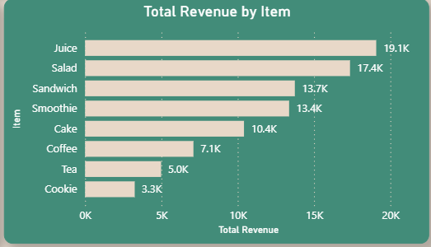  Figure 1. Total Revenue by Item (Power BI) |  |  | 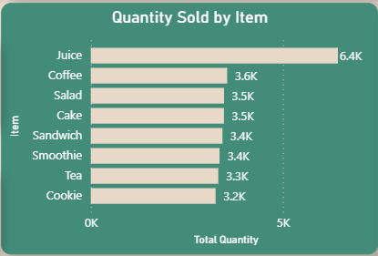  Figure 2. Quantity Sold by Item (Power BI)
Observations:
- Juice leads both revenue ($19,075.50) and units (6,435). The other seven items each sold between about 3,250 and 3,550 units.
- Products with similar unit volumes earn very different revenue because of price: Salad earned $17,358 from 3,469 units while Cookie earned only $3,253 from 3,249 units.
- Juice, Salad, Sandwich and Smoothie together contribute about 71.16% of revenue; Cookie and Tea together contribute less than 10%.

6.4 Payment Method and Location
Payment method | Revenue | Share | Transactions | Units
Digital Wallet | $48,354.00 | 54.15% | 5,469 | 16,563
Credit Card | $20,483.00 | 22.94% | 2,273 | 6,866
Cash | $20,453.50 | 22.91% | 2,258 | 6,842
Total | $89,290.50 | 100.00% | 10,000 | 30,271

Location | Revenue | Share | Transactions | Units
Takeaway | $62,039.00 | 69.48% | 6,983 | 21,132
In-store | $27,251.50 | 30.52% | 3,017 | 9,139
Total | $89,290.50 | 100.00% | 10,000 | 30,271

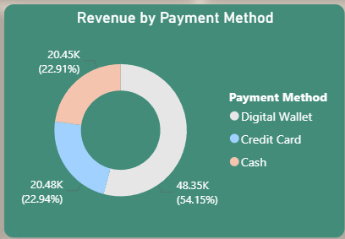  Figure 3. Revenue by Payment Method (Power BI) | 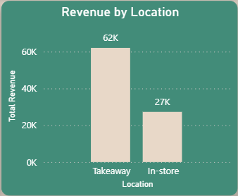  Figure 4. Revenue by Location (Power BI)
Average transaction value is almost identical across payment methods ($8.84 to $9.06) and across locations ($8.88 Takeaway, $9.03 In-store), so differences in revenue in the reported data come from the number of transactions rather than from the value per transaction.

6.5 Monthly Trend
Month | Revenue | % of year | Transactions | Units
Jan | $7,280.00 | 8.15% | 818 | 2,463
Feb | $6,657.50 | 7.46% | 727 | 2,248
Mar | $7,231.50 | 8.10% | 827 | 2,480
Apr | $7,208.00 | 8.07% | 774 | 2,387
May | $7,011.50 | 7.85% | 777 | 2,342
Jun | $7,364.00 | 8.25% | 818 | 2,471
Jul | $11,058.50 | 12.38% | 1,251 | 3,782
Aug | $7,096.50 | 7.95% | 803 | 2,405
Sep | $6,880.00 | 7.71% | 788 | 2,363
Oct | $7,322.00 | 8.20% | 838 | 2,535
Nov | $6,973.00 | 7.81% | 784 | 2,352
Dec | $7,208.00 | 8.07% | 795 | 2,443
Total | $89,290.50 | 100.00% | 10,000 | 30,271
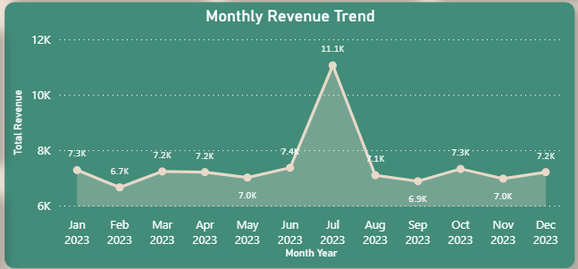
Figure 5. Monthly Revenue Trend (Power BI)
Eleven of the twelve months fall in a narrow band of about $6,650 to $7,400. July stands out at $11,058.50, roughly 55.5% above the average of the other eleven months. February is the lowest month at $6,657.50 (it is also the shortest month).

6.6 Spending Pattern and High-Value Transactions
The IQR method was used to flag unusually large transactions. With Q1 = $4, Q3 = $12 and IQR = $8, the upper fence is $24. All 268 transactions above that fence have a value of exactly $25.00 and are labelled "Potential High-Value Outlier" in the Transaction Type column.
Metric | Value
Potential high-value transactions | 268 (2.68% of all transactions)
High-value revenue | $6,700.00 (7.50% of total revenue)
Normal transactions | 9,732 transactions; $82,590.50 revenue; values $1.00 to $20.00
High-value by item | Salad 247 transactions ($6,175; 92.16% of high-value revenue); Juice 21 transactions ($525)
These transactions are best described as high-value rather than erroneous: a $25.00 sale is simply the largest basket the menu allows (5 Salads at $5.00). They are worth reviewing as a valuable customer behaviour, not removing as anomalies.

6.7 Excel Dashboard
The Dashboard sheet, titled "CAFE SALES ANALYSIS DASHBOARD", presents KPI cards (Total Transaction 10,000; Total Revenue $89,290.50; Average Transaction $8.93; Total Quantity Sold 30,271), charts for Revenue by Product, Quantity Sold by Product, Revenue by Payment Method, Revenue by Location, Monthly Revenue Trend and a "Cafe Sales Frequency" histogram of transaction values, together with three slicers (Item, Location, Payment Method) connected to the pivot tables.

6.8 Insights Recorded in the Excel Workbook
- Product: Juice generated the highest revenue ($19,075.50) and quantity (6,435 units), about 21.36% of total revenue.
- Payment method: Digital Wallet was dominant at $48,354.00, about 54.15% of revenue.
- Location: Takeaway generated $62,039.00 (about 69.48%) versus $27,251.50 In-store.
- Monthly trend: July was highest at $11,058.50; February was lowest at $6,657.50.
- Spending pattern: average transaction $8.93 versus median $8.00, showing that higher-value transactions pull the average above the median.
- Anomalies: the IQR upper threshold was $24.00, and 268 transactions of $25.00 were flagged as potential high-value outliers for review.
- Product comparison: similar unit volumes can produce very different revenue depending on price per unit (Salad vs Cookie).

7. Interactive Dashboard (Power BI)

7.1 Overview
The Power BI report (SWYNEX-Interactive-Dashboard.pbix) provides an interactive layer on top of the cleaned data. It uses two related tables, CafeSales (transactions) and DateTable (calendar dimension), and contains three 16:9 report pages (1280 x 720): Dashboard, Business Insights and Executive Insights. The main dashboard visuals are filtered to the 2023 calendar year (>= 2023-01-01 and < 2024-01-01).
Page | Purpose | Components
1. Dashboard | Overall performance monitoring and interactive exploration | 5 KPI cards, monthly trend, item revenue, item quantity, payment method donut, location column chart, 5 slicers
2. Business Insights | Deeper decision-oriented analysis | Top item card, revenue concentration donut, transaction type pie, payment bar chart, highest / lowest month cards, high-value KPI cards and chart
3. Executive Insights | Management summary | 10 consolidated, quantified findings

7.2 Page 1: Dashboard
Titled "CAFE SALES PERFORMANCE DASHBOARD". Five KPI cards run across the top, with slicers down the left side and five charts below.
KPI card | Measure | Value
Total Revenue | Total Revenue | $89,290.50
Total Transactions | Total Transaction | 10,000
Total Quantity | Total Quantity | 30,271 units
Average Transaction Value | Average Transaction Value | about $8.93
Average Quantity per Transaction | Average Quantity per Transaction | about 3.03

Visual | Chart type | Fields
Monthly Revenue Trend | Line chart | DateTable[Month Year] by Total Revenue
Revenue by Item | Clustered bar | CafeSales[Item] by Total Revenue
Quantity Sold by Item | Clustered bar | CafeSales[Item] by Total Quantity
Revenue by Payment Method | Donut | CafeSales[Payment Method] (with Location) by Total Revenue
Revenue by Location | Clustered column | CafeSales[Location] by Total Revenue

Slicers: Item, Date (DateTable), Payment Method, Location and Transaction Type. Changing any slicer updates all KPI cards and charts on the page.

7.3 Page 2: Business Insights
Visual / measure | Type | What it shows
Top Revenue / Quantity | Card (Top 1 item by revenue) | The leading product
Revenue Concentration by Item | Donut | Distribution of revenue across the eight items
Transaction Type Distribution | Pie | Revenue split between Normal and Potential High-Value transactions
Payment Method Revenue Contribution | Clustered bar | Revenue by payment method
Highest Revenue Month | Card (Top 1 month) | July, $11,058.50
Lowest Revenue Month | Card (Bottom 1 month) | February, $6,657.50
High-Value Transactions | Card | 268 transactions
High-Value Revenue | Card | $6,700
High-Value Revenue % | Card | about 7.50%
Potential High-Value Transactions by Item | Clustered column | High-value count per item (Salad dominant)

7.4 Page 3: Executive Insights
A single text page listing the ten management findings with quantified results. These are reproduced and interpreted in Section 8.

7.5 Measures and Data Model
Measure | Purpose | Value in report
Total Revenue | Sum of Total Spent | $89,290.50
Total Transaction | Count of transactions | 10,000
Total Quantity | Sum of Quantity | 30,271
Average Transaction Value | Total Revenue divided by Total Transaction | about $8.93
Average Quantity per Transaction | Total Quantity divided by Total Transaction | about 3.03
Highest Month Info | Top-1 month by revenue | July, $11,058.50
Lowest Month Info | Bottom-1 month by revenue | February, $6,657.50
High-Value Transactions | Count of potential high-value transactions | 268
High-Value Revenue | Revenue of those transactions | $6,700
High-Value Revenue % | High-value revenue divided by total revenue | about 7.50%
Note on definitions: the measure names and values above are taken from the report pages and were reconciled to the cleaned dataset. The high-value classification matches the Excel Transaction Type rule (Total Spent above the IQR upper bound of $24, i.e. $25), which reproduces the report figures exactly (268 transactions, 2.68%, $6,700, 7.50%). The DAX expressions inside the .pbix data model are stored in a compressed format, so the exact formula text is best confirmed by opening the file in Power BI Desktop.

7.6 Interactivity and Usage
- Select a slicer value (for example one item, one payment method or a date range) and every connected card and chart recalculates.
- Use the Monthly Revenue Trend to spot peaks, then filter by Item or Location to see what drives them.
- Use the Business Insights page for concentration and high-value analysis, and the Executive Insights page for a shareable summary.
- Note that executive figures are report-level findings and change when filters are applied elsewhere in the report.

7.7 Technical Components
Cards, line chart, clustered bar and column charts, donut and pie charts, interactive slicers, dedicated DAX measures, a date dimension for time filtering, and Top-N filters for the leading item and the highest / lowest month.

8. Key Business Insights
The table below lists the ten Executive Insights from the dashboard, with a business interpretation for each. Figures are shown as published in the dashboard; Section 9 explains how confident to be in each one.
# | Insight | Finding (as reported) | Business interpretation
1 | Overall performance | $89,290.50 revenue, 10,000 transactions, 30,271 units | Average basket of about $8.93 and 3 units; the baseline for all targets.
2 | Product performance | Juice: $19,075.50, 21.36% of revenue | Largest single revenue contributor in the reported data.
3 | Revenue concentration | Juice, Salad, Sandwich, Smoothie = 71.16% of revenue | Half the menu drives most revenue; a supply or quality problem in these items has an outsized impact.
4 | Sales volume | Juice: 6,435 units | Highest-volume item; other items sit near 3,250 to 3,550 units.
5 | Payment behaviour | Digital Wallet: $48,354, 54.15% | Digital payments are central; wallet outages or fees would affect more than half of reported revenue.
6 | Location performance | Takeaway: $62,039, 69.48%, 6,983 transactions | Takeaway is the main channel; packaging, speed and pickup experience matter most.
7 | Monthly performance | July: $11,058.50, about 55.5% above other-month average | A pronounced single-month peak; worth investigating what happened (event, promotion, data effect).
8 | High-value transactions | 2.68% of transactions, about 7.50% of revenue | A small segment of large baskets punches above its weight.
9 | High-value concentration | Salad: about 92% of high-value revenue | Large-basket behaviour is a Salad phenomenon (highest price, up to 5 units).
10 | Transaction value | Salad average about $15.12 | Highest value per transaction of any item.

Power BI Business Insights visuals:
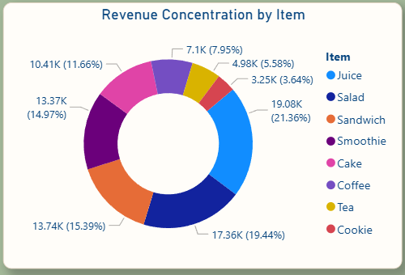  Figure 6. Revenue Concentration by Item (Power BI) | 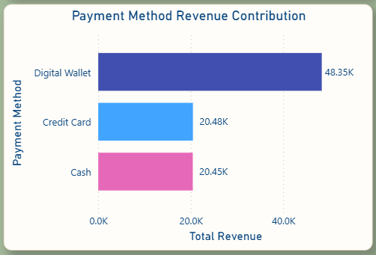  Figure 7. Payment Method Revenue Contribution (Power BI)
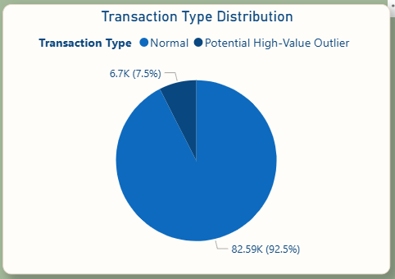  Figure 8. Transaction Type Distribution (Power BI) | 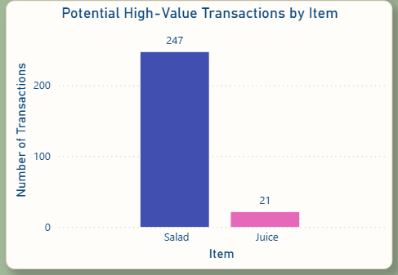  Figure 9. Potential High-Value Transactions by Item (Power BI)

8.1 Additional Analytical Insights
- Price drives revenue, not volume. Average quantity per transaction is close to 3 for every item (2.98 to 3.06), so revenue differences between items come almost entirely from unit price. Salad ($5.00), Sandwich ($4.00) and Smoothie ($4.00) earn roughly $12 to $15 per transaction, while Cookie ($1.00) and Tea ($1.50) earn about $3 to $4.60.
- Spending is right-skewed. Mean $8.93 versus median $8.00, with 268 transactions at the $25 maximum.
- Basket value is uniform across channels and payment types. Average transaction value ranges only from $8.84 to $9.06 across payment methods and from $8.88 to $9.03 across locations.
- Low-price items are the smallest contributors. Cookie and Tea together are 9.2% of revenue on about 22% of units, which suggests room for bundling or upselling.
- Concentration is moderate rather than extreme. The top item holds 21.36% and the top four hold 71.16%.

9. Data Validation Review
As part of preparing this report, the cleaned dataset was compared with the original dirty file. The purpose is to confirm which insights rest on observed data and which may be shaped by the cleaning method. This review does not change the dashboard; it adds context and a path to a more accurate second iteration.

9.1 What the Original Data Shows
Using only the values that were actually recorded in the raw file (ERROR, UNKNOWN and blanks excluded), the distributions are almost perfectly even:
Dimension | Recorded values only (raw file) | Cleaned dataset (after imputation)
Item (share of transactions) | Each item between 12.1% and 13.0%; Juice 12.97% | Juice 21.40% (2,140 transactions); others 10.9% to 11.7%
Payment method (share of transactions) | Digital Wallet 33.58%, Credit Card 33.32%, Cash 33.10% | Digital Wallet 54.69% (5,469); Credit Card 22.73%; Cash 22.58%
Location (share of transactions) | Takeaway 50.04%, In-store 49.96% | Takeaway 69.83% (6,983); In-store 30.17%
July transactions | 791 (in line with other months, 727 to 838) | 1,251
Transactions on 2 July 2023 | Normal daily level (about 27) | 489

9.2 Why It Happens
- Mode imputation filled 969 missing Items with Juice, 3,178 missing Payment Methods with Digital Wallet and 3,961 missing Locations with Takeaway. These are exactly the categories that then appear as dominant.
- Median-date imputation assigned all 460 missing dates to 2 July 2023. That single day therefore has 489 transactions (against a daily average of about 27) and produces the July peak.
- Median numeric imputation set Price Per Unit to $3.00 and Quantity to 3 regardless of the item, so 753 rows (7.53%) no longer satisfy Total Spent = Quantity x Price Per Unit, whereas the raw file satisfied it in 100% of the 8,544 rows where all three were recorded. Quantity = 3 accounts for 2,328 rows against roughly 1,820 to 2,010 for each other quantity.
- Impossible combinations appeared: 21 Juice transactions carry a total of $25.00, which cannot occur at a $3.00 price and a maximum quantity of 5.

9.3 Impact on the Ten Insights
Insight | Confidence | Comment
1. Overall totals | Moderate | Revenue, units and average are estimates because about 5% of numeric values were imputed.
2 and 4. Juice leads revenue and volume | Low | Largely a result of assigning 969 unknown items to Juice. On rows with a recorded item, Juice has about 13% of transactions, similar to every other item.
3. Concentration in four products | Moderate to high | The pattern is price-driven and holds up: on recorded data the top four by revenue (Salad, Sandwich, Smoothie, Juice) hold about 68%.
5. Digital Wallet dominance | Low | On recorded values the three payment methods are about one-third each.
6. Takeaway dominance | Low | On recorded values Takeaway and In-store are about 50 / 50.
7. July peak | Low | Driven by 460 missing dates assigned to 2 July. Recorded dates show a flat monthly profile.
8. High-value share | Moderate | The $25 threshold is genuine (5 Salads), but 21 of the 268 flagged rows are Juice artefacts.
9 and 10. Salad and high-value / transaction value | High | Driven by the fixed $5.00 price and is consistent in both raw and cleaned data.

9.4 A Price-Based Reconstruction
Using only the 8,611 raw rows where both Item and Quantity were recorded, and valuing each at the fixed menu price, gives an indicative revenue split that is not affected by imputation:
Item | Indicative revenue share | Item | Indicative revenue share
Salad | 21.47% | Cake | 12.96%
Sandwich | 16.84% | Coffee | 8.74%
Smoothie | 16.72% | Tea | 6.14%
Juice | 13.13% | Cookie | 4.01%
On this basis Salad, not Juice, is the largest revenue item, and the four premium-priced items (Salad, Sandwich, Smoothie, Juice) contribute about 68% of revenue.

10. Business Recommendations

10.1 Recommendations Supported by the Data
Area | Recommendation | Basis
Product mix | Protect availability and quality of Salad, Sandwich, Smoothie and Juice, which drive about 68% to 71% of revenue. | Revenue concentration (Insight 3 and Section 9.4).
Basket building | Bundle or upsell low-price items (Cookie, Tea, Coffee) with premium items to lift average basket value. | Cookie and Tea earn under 10% of revenue on about 22% of units.
Premium items | Promote Salad as a flagship: it has the highest average transaction ($15.12) and generates most $25 baskets. | Insights 9 and 10.
High-value customers | Introduce multi-unit offers or loyalty rewards for large baskets. | 268 transactions at $25 contribute 7.5% of revenue.
Pricing | Test small price adjustments on the volume-heavy, lower-priced items; unit volumes are similar across items so price is the main revenue lever. | Section 8.1.

10.2 Recommendations Contingent on Validation
The following actions depend on confirming the reported patterns with cleaner data (Section 9):
- If Digital Wallet dominance is confirmed, encourage wallet payments with offers and ensure payment-system reliability; otherwise maintain a balanced payment mix.
- If Takeaway dominance is confirmed, invest in packaging, pickup speed and pre-ordering; otherwise balance investment between channels.
- Investigate July: check whether a real event, promotion or seasonal effect occurred, and whether missing dates inflated it.

11. Limitations and Assumptions
- The dataset covers a single year (2023) and one business, so seasonality cannot be confirmed.
- There are no cost, margin, customer ID, staff or time-of-day fields, so profitability, retention and peak-hour analysis are not possible.
- Between 4.6% and 39.6% of values in individual columns were imputed, which affects the reliability of the dimension-level insights (see Section 9).
- Prices appear fixed per item in the raw data; the analysis assumes no discounts or promotions.
- The term "potential high-value transaction" is a statistical classification (Total Spent above the IQR upper fence), not a customer-value judgement.
- Dashboard figures are report-level findings and change when slicers are applied.
- The .pbix DAX expressions are stored in a compressed data model and were not read directly; measure definitions were reconciled to the cleaned data instead.

12. Conclusion
The SWYNEX project delivers a complete analytics lifecycle on a realistic, error-ridden cafe sales dataset: profiling and cleaning in Python, exploratory analysis in Excel, an interactive three-page Power BI dashboard, and a set of quantified business insights. The cleaned dataset covers 10,000 transactions and $89,290.50 of revenue, and the dashboard lets management explore performance by product, payment method, channel, month and transaction type.
The strongest and most reliable conclusion is that price determines revenue: premium-priced items (especially Salad) generate most revenue and nearly all high-value baskets, while low-priced items add units but little revenue. With a little refinement, the same dashboard and workflow can serve as a dependable, recurring management tool for sales planning, promotions and product decisions.

Appendix A: Key Cleaning Code
A condensed version of the notebook logic (the notebook applies the same fills column by column):
df = pd.read_csv("dirty_cafe_sales.csv")
df = df.replace(["ERROR", "UNKNOWN"], np.nan)
for col in ["Quantity", "Price Per Unit", "Total Spent"]:
df[col] = pd.to_numeric(df[col], errors="coerce")
df["Transaction Date"] = pd.to_datetime(df["Transaction Date"], errors="coerce")
for col in ["Item", "Payment Method", "Location"]:
df[col] = df[col].fillna(df[col].mode()[0])
for col in ["Quantity", "Price Per Unit", "Total Spent"]:
df[col] = df[col].fillna(df[col].median())
df["Transaction Date"] = df["Transaction Date"].fillna(median_date) # 2023-07-02
df["Quantity"] = df["Quantity"].round().astype(int)
df[["Price Per Unit", "Total Spent"]] = df[["Price Per Unit", "Total Spent"]].round(2)
df.to_csv("cleaned_cafe_sales.csv", index=False)

Appendix B: Glossary
Term | Meaning
Imputation | Replacing missing values with estimated values such as the mode or median.
Mode / Median | Most frequent value / middle value of a column.
IQR | Interquartile range (Q3 minus Q1); the fences Q1 - 1.5 x IQR and Q3 + 1.5 x IQR are used to flag outliers.
Potential High-Value Transaction | A transaction whose value exceeds the IQR upper fence ($24), i.e. $25.
KPI | Key performance indicator, such as total revenue or average transaction value.
DAX | Data Analysis Expressions, the formula language used for Power BI measures.
Slicer | An interactive filter control in Excel or Power BI.
Revenue concentration | The share of total revenue held by a small number of products.

Appendix C: Author and Verification
Item | Detail
Author | Pritam Dey
Project | SWYNEX Interactive Cafe Sales Dashboard
Power BI report | SWYNEX-Interactive-Dashboard.pbix (pages: Dashboard, Business Insights, Executive Insights)
Documentation | SWYNEX-Interactive-Dashboard-README.md (dated September 28, 2026)
Verification | Open the .pbix and cross-check KPI cards, slicers, visuals and measures on all three pages against Sections 7 and 8; all reported figures were also recomputed from cleaned_cafe_sales.csv for this report.

